CO3- AT2- Tree Traversal Visualization Visualize the Tree Traversal CSA0315 – Data Structures
MONIGA V- 192521184

- Construct a Binary Search Tree (BST) using the dataset 45, 20, 60,
10, 30, 50, 70, 25, 35
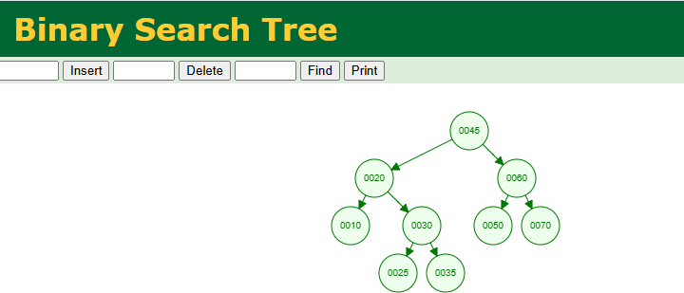

- Construct an AVL Tree using the elements 50, 30, 70, 20, 40, 60, 80, perform the required operation and document the results. Delete node 30
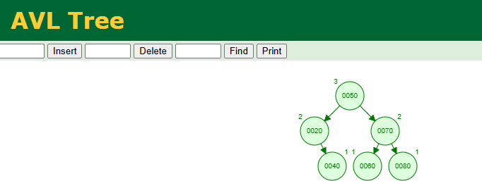

- Construct a Red-Black Tree using {45, 35, 55, 25, 40, 50, 60}, delete the node 35, and explain how violations are fixed using rotations and recoloring

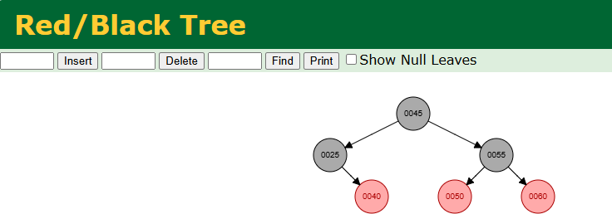

- Develop a Splay Tree with elements {100, 50, 200, 40, 30, 20}, perform a search operation for 20, and demonstrate the zig-zig rotations that bring it to the root
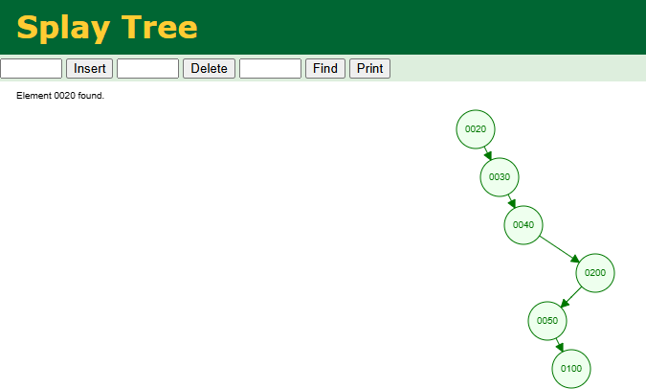

- Create a 2-3-4 Tree for the dataset {50, 40, 60, 30, 70, 20, 80}, perform insertions step-by-step, and show how 4-nodes are split during the process.
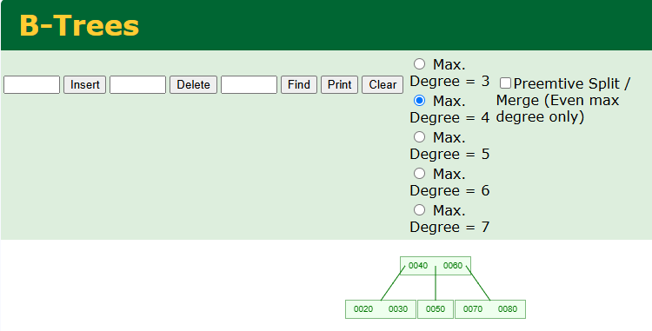
- Construct a Trie using the words {cat, car, care, dog, dot}, perform insertion for all words, search for the prefix “ca”, and delete the word “car” while maintaining the Trie structure.
